  Tuesday May 8th 7pm-8:30pm  LEARN to use the city’s Crime database  Join Rose Park Neighborhood’s Workshop hosted at 7th St. Church (E7th & Obispo).  On hand will be Commander Eric Herzog and the Eastside LB Police Department’s criminologist. Learn to navigate the city’s new crime database. Help your organization, neighborhood or community watch monitor and reduce crime in our area.  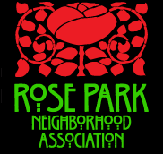  For over 30 years working to support the residents, business and property owners in the Rose Park Neighborhood! | We can’t prevent what we don’t recognize  ────  Ask the questions you and your neighbors want answered  ────  The crime db is at http://datalb.longbeach.gov/datasets?q=crime  ────  Thank you to  7th St. Church for hosting this key workshop  ────  Be in the Know  Rose Park Neighborhood  Association  info@rpna.org  www.rpna.org

